Company Dash history backups and settings
Document 36 of the Nexora learning guides
Source snapshot 14 October 2026 at 06:41 UTC
Locate persistent history, usage controls, backup verification and deliberate restoration.

Recognise the screen and its scope
Open http://127.0.0.1:8000/#activity, http://127.0.0.1:8000/#settings. Company Dash uses loopback port 8000 and hash navigation. Open its separate repository in VS Code before Ctrl+P. The source library uses company-dash as a project label, not a Nexora folder.
This guide covers SQLite history and activity; Configuration diagnostics; Provider token usage; Optional usage thresholds; Checksummed backups; Restore to a new directory; Opt-in workspace retention.
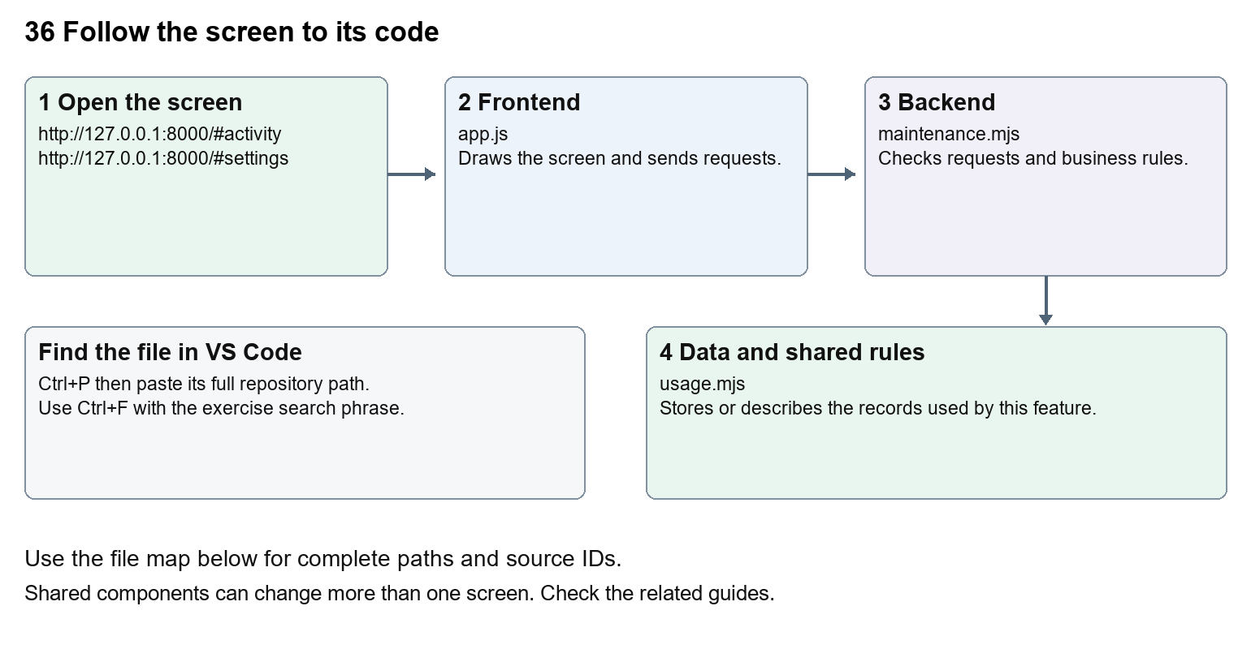
The diagram shows the file roles. The full paths below are what you paste into Ctrl+P.

Find the files in VS Code
Role | File and source ID | What it does
Screen | S0696 app.js | Main UI or route for this topic
Server | S0706 maintenance.mjs | Endpoints or server rules
Data | S0712 usage.mjs | Data shape or persistence structure

Screen S0696
public/app.js
Server S0706
server/maintenance.mjs
Data S0712
server/usage.mjs
Use the HTML source buttons for full files. Word shows labelled extracts; individual Markdown guides contain complete primary files.

Follow the request and the records
1. Activity displays stored events; settings reads safe configuration and usage summaries from /api/state.
2. Budget calculations combine provider usage with explicitly configured rates when available.
3. Create backup requests POST /api/maintenance/backup after active and queued work has stopped.
4. The server copies the database, reports and relevant workspaces and verifies a checksummed manifest.
5. The restore command checks the backup and writes to a new data directory; retention previews precede deliberate cleanup.

Read the code with an explanation
data/ contains the SQLite database, reports and isolated workspaces and stays outside Git and the source library. config.local.json contains workstation settings; config.example.json explains the keys without revealing private values. Token usage is provider-reported. Dollar estimates need explicit rates; subscription billing is not inferred. Zero-valued thresholds and retention mean disabled defaults. Backups omit regenerable dependencies and build output. server/restore.mjs calls restoreBackup from maintenance.mjs and expects a backup directory and a new destination.
Source reference S0696 company-dash/public/app.js
Extract from source line 63. A fragment from a long line is shown without the rest of that line.
0063 function settings() { const d=state.data; return heading('Worksp

index.html supplies markup and app.js renders browser views. Follow api() to the server route handler.
Source reference S0706 company-dash/server/maintenance.mjs
Extract from source line 25. A fragment from a long line is shown without the rest of that line.
0025 export async function backupData(store, config) {

The browser api() helper sends a method and local request token. app.mjs checks the route and calls the relevant service. Follow that call to understand SQL writes, process execution and filesystem changes.
Source reference S0712 company-dash/server/usage.mjs
Selected opening lines with their original numbers. The complete file is in the HTML source library.
0001 export function usageTotal(usage) { return (usage?.input_tokens || 0) + (usage?.output_tokens || 0); }
0002 export function estimateCost(usage, rates) {
0003 if (!usage || !rates) return null;
0004 return ((usage.input_tokens - usage.cached_input_tokens) * rates.input + usage.cached_input_tokens * rates.cached + usage.output_tokens * rates.output) / 1000000;
0005 }
0006 export function usageParser(onUsage) {

store.mjs defines SQLite history tables. catalog.mjs and config.mjs define configuration; repository.mjs records fingerprints. Trace each key into its service before assuming it is a stored table.

Make or trace your first change
1. Press Ctrl+P and open server/maintenance.mjs.
2. Press Ctrl+F and search for export async function backupData. In this snapshot it appears at line 25.
3. Read-only exercise: find how backupData creates its manifest and how restoreBackup verifies each file. Then find retentionPlan and explain why previewing it does not delete history.
4. Record the file, request path and server handler you found. This exercise is read-only; no stored records need to change.
Extract from source line 25. A fragment from a long line is shown without the rest of that line.
0025 export async function backupData(store, config) {

These exercises have not been applied to the application. Their search phrases are verified against the captured source. Line numbers can move; the phrase and file path are your main navigation aids.

Check a change and diagnose problems
Confirm the original screen still loads, the changed words appear in the intended place, and another screen using the same component still behaves correctly. If an action fails, inspect the browser Network response, the relevant helper and server validation message. Use the common error table at the beginning of the manual. Reload on a version conflict instead of removing the version check.
A syntax error after a text edit usually means a quote, brace or closing tag changed. Compare your diff with the original. An unchanged browser result can mean the wrong port, a saved published configuration overriding a default, or a running API that has not reloaded.

Understand the current limits
Usage thresholds act at provider turn boundaries and cannot guarantee an exact in-flight spending cap. A backup is not a successful restore test. Do not run cleanup or restoration against existing history while learning; the documentation task performs neither action.

Continue learning
Related guides 31 Company Dash startup and dashboard, 33 Company Dash tasks agents and handoffs, 35 Company Dash proposal review and integration.

